
Viewed by:
Philippe POHER
Tel.: +33 (0)2 99 27 92 92
E-mail: philippe.poher@iwedia.com

Written by:
Philippe POHER
Tel.: +33 (0)2 99 27 92 92
E-mail: philippe.poher@iwedia.com
IWEDIA

TDAL_KBD Technical Specifications

V2.0

Approved by:
Thierry GARNIER
Tel.: +33 (0)2 99 27 92 92
E-mail: thierry.garnier@iwedia.com

SUMMARY
1 Reference documents 3
2 Documentation History 4
3 Introduction 5
4 Module Overview and Architecture 6
4.1 Definitions, Acronyms and Abbreviations 6
4.2 General Description 7
4.2.1 Interactions with other TDAL modules 8
4.3 Architecture 8
4.4 TDAL_KBD API Description 9
4.4.1 Generic Interface 9
5 TDAL_KBD API Specification 10
5.1 Type Specifications 10
5.1.1 Generic 10
5.2 TDAL_KBD API Usage 11
5.2.1 Read/Write Data Processings 11
5.3 TDAL_KBD Macro/Define/Enum/Typedef/Structure Definitions 12
5.3.1 Define Definitions 12
5.3.1.1 kTDAL_KBD_NO_ID 12
5.3.1.2 kTDAL_KBD_NO_KEY 12
5.3.1.3 kTDAL_KBD_NB_MAX_CLIENTS 12
5.3.2 Enum Definitions 13
5.3.2.1 tTDAL_KBD_ErrorCode; 13
5.3.2.2 tTDAL_KBD_KeyStatus 13
5.3.3 Typedef Definitions 13
5.3.3.1 tTDAL_KBD_ClientId 13
5.3.3.2 tTDAL_KBD_KeyCode 13
5.3.3.3 tTDAL_KBD_CallbackFct 14
5.3.4 Structure Definitions 15
5.4 TDAL_KBD API Functions 16
5.4.1 Generic Interface API 16
5.4.1.1 TDAL_KBD_Init(-) 16
5.4.1.2 TDAL_KBD_Term(-) 17
5.4.1.3 TDAL_KBD_Register(-) 18
5.4.1.4 TDAL_KBD_UnRegister(-) 19
5.4.1.5 TDAL_KBD_SetMapping(-) 20
6 TDAL_KBD External Dependencies 21
6.1.1.1 tTDAL_KBD_CallbackFct 21

Reference documents
The following documents were used to write this specification:

Document | Version | Title

Documentation History

History
Vers. | Date | Nature
2.0 | 17/01/2008 | PPO: First version of TDAL_KBD

Introduction
The purpose of this document is to specify the interface and to describe the internal design of the Thin Driver Adaptation Layer for Keyboard [TDAL_KBD]. The aim of this module is to provide a complete interface between middlewares and the keyboard stage low level driver of a set-top-box.

Module Overview and Architecture

Definitions, Acronyms and Abbreviations
CHAL | Comedia hardware Adaptation Layer, composed of TDALs driver, TKEL and TBOX module
TDAL | Thin Driver Adaptation Layer
TKEL | Thin Kernel Encapsulation Layer
TBOX | Tool Box

General Description
The main job of the TDAL_KBD is to get the keyboard events from a remote control.

For each action done by the end-user on the remote control, the TDAL_KBD aims at creating an event which may be interpret by the client to process an action.

The client gives the key code array of button managed by the application.

The TDAL_KBD may interpret the following state of a button:

- PRESSED
- RELEASED
- HELD DOWN

Interactions with other TDAL modules

Architecture
The figure below shows the relation between the client module and the low level drivers:
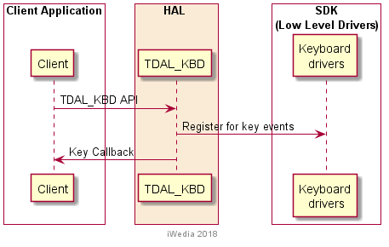

TDAL_KBD API Description

Generic Interface
The generic interface allows clients to control the TDAL_KBD module.
This interface is used with the following functions:
- TDAL_KBD_Init(-) in order to initialize the TDAL_KBD module.
- TDAL_KBD_Term (-) in order to terminate the TDAL_KBD module.
- TDAL_KBD_Register(-) in order to register one client to TDAL_KBD
- TDAL_KBD_Unregister(-) in order to unregister one client to TDAL_KBD
- TDAL_KBD_SetKeyMapping(-) in order to get data on the instance.

TDAL_KBD API Specification

Type Specifications

Generic
tTDAL_KBD_ErrorCode is the error code return by TDAL_KBD function.
tTDAL_KBD_ClientId is the type which defines the value used to identify a client of TDAL_KBD.
tTDAL_KBD_KeyStatus is an enumeration of different state of the button to define the event happens.
tTDAL_KBD_CallbackFct is the callback to implement by the client to receive event notification.

TDAL_KBD API Usage

Event reception processing
The initialisation of TDAL_KBD API is made.

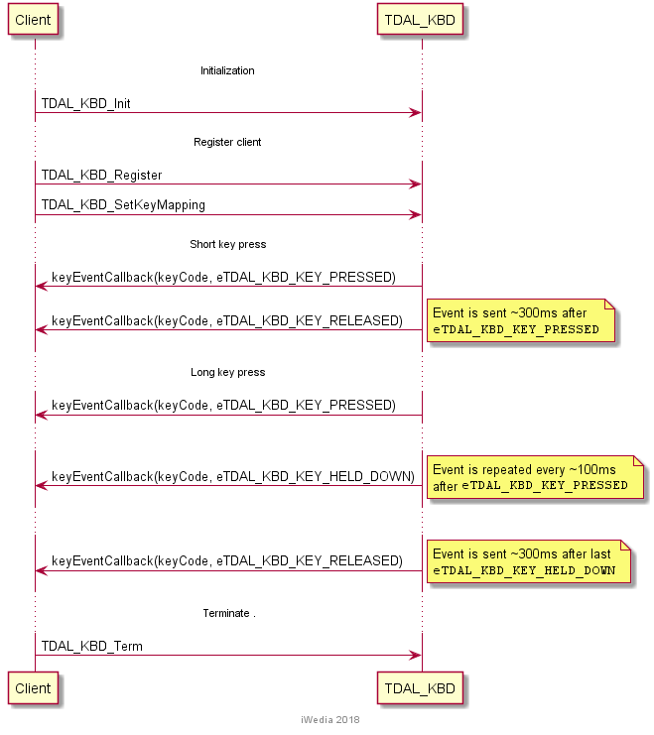

TDAL_KBD Macro/Define/Enum/Typedef/Structure Definitions

Define Definitions

kTDAL_KBD_NO_ID
This constant is used to define the invalide client Id value
#define kTDAL_KBD_NO_ID -1

kTDAL_KBD_NO_KEY
This value is used to define invalid Ky value.
#define kTDAL_KBD_NO_KEY 0

kTDAL_KBD_NB_MAX_CLIENTS
This constant is used to define maximum client supported by TDAL_KBD.
#define kTDAL_KBD_NB_MAX_CLIENTS 1

Enum Definitions

tTDAL_KBD_ErrorCode;
An enumeration of the different possible error value handled by TDAL_KBD.
typedef enum {
eTDAL_KBD_NO_ERROR,
eTDAL_KBD_ERROR
}tTDAL_KBD_ErrorCode;

tTDAL_KBD_KeyStatus
An enumeration of the different possible status of button event.

typedef enum {
eTDAL_KBD_KEY_PRESSED,
eTDAL_KBD_KEY_RELEASED,
eTDAL_KBD_KEY_HELD_DOWN
}tTDAL_KBD_KeyStatus;

Typedef Definitions

tTDAL_KBD_ClientId
This type enables to define client identifier type.
typedef int16_t tTDAL_KBD_ClientId;

tTDAL_KBD_KeyCode
This type enables to define key code value of remote control protocol.
typedef uint32_t tTDAL_KBD_KeyCode;

tTDAL_KBD_CallbackFct
This typedef defines the callback type registered by the client to receive TDAL_KBD events
typedef void (*tTDAL_KBD_CallbackFct) (
tTDAL_KBD_KeyCode KeyCode,
tTDAL_KBD_KeyStatus KeyStatus
);

Parameters:
Parameter | Type | Dir | Description
KeyCode | tTDAL_KBD_KeyCode | In | Keycode event received
KeyStatus | tTDAL_KBD_KeyStatus | In | Type of action done on remote control button

Structure Definitions
None

TDAL_KBD API Functions

Generic Interface API

TDAL_KBD_Init(-)
Prototype:
tTDAL_KBD_Error TDAL_KBD_Init (void);
Description:
This function initialises the TDAL_KBD module.
Return value:
It returns eTDAL_KBD_NO_ERROR if initialization succeed.
It could eTDAL_KBD_ERROR otherwise.
Parameters:
None.
Comments:
This function must be called before any other functions of the TDAL_KBD API.
See Also:
TDAL_KBD_Term(-).

TDAL_KBD_Term(-)
Prototype:
tTDAL_KBD_Error TDAL_KBD_Term (void);
Description:
This function terminates the TDAL_KBD module.
Return value:
It returns eTDAL_KBD_NO_ERROR if termination succeed.
It could eTDAL_KBD_ERROR otherwise.
Parameters:
None.
Comments:
Any function of TDAL_KBD API should not be called after TDAL_KBD_Term(-) call.
See Also:
TDAL_KBD_Init(-).

TDAL_KBD_Register(-)
Prototype:
tTDAL_KBD_ClientId TDAL_KBD_Register(
tTDAL_KBD_CallbackFct callback /* I: Function called upon key events */
);
Description:
This function enables a client to register itself to TDAL_KBD to receive remote control events associated to the end-user action

Return value:
It returns the client Id if register succeeds. Else return kTDAL_KBD_NO_ID.
Parameters:
Parameter | Type | Dir | Description
callback | tTDAL_KBD_CallbackFct | In | Callback to register to client.
Comments:
This function can be called at any time the TDAL_KBD has been initialised with TDAL_KBD_Init(-) but not after the termination with TDAL_KBD_Terminate(-).
See Also:

TDAL_KBD_UnRegister(-)
Prototype:
tTDAL_KBD_ErrorCode TDAL_KBD_UnRegister(
tTDAL_KBD_ClientId clientId /* I: Id of the client to unregister */
);
Description:
This function unregisters a client from TDAL_KBD
Return value:
It returns eTDAL_KBD_NO_ERROR if termination succeed.
It could eTDAL_KBD_ERROR otherwise.
Parameters:
Parameter | Type | Dir | Description
clientId | tTDAL_KBD_ClientId clientId | In | Client identifier
Comments:
This function can be called at any time the TDAL_KBD has been initialised with TDAL_KBD_Init(-) but not after the termination with TDAL_KND_Term(-).
See Also:
tTDAL_KBD_ClientId

TDAL_KBD_SetMapping(-)
Prototype:
tTDAL_KBD_ErrorCode TDAL_KBD_SetKeyMapping(
unsigned short NbKeys,
tTDAL_KBD_KeyCode *KeyCode
);
Description:
This function gives the number of remote control button (available on the remote control) to manage and their key code.
Return value:
It returns eTDAL_KBD_NO_ERROR if termination succeed.
It could eTDAL_KBD_ERROR otherwise.
Parameters:
Parameter | Type | Dir | Description
NbKeys | unsigned short | In | Nb keys to manage
KeyCode | tTDAL_KBD_KeyCode | In | Key button arrays
Comments:
This function can be called at any time the TDAL_KBD has been initialised with TDAL_KBD_Init(-) but not after the termination with TDAL_KBD_Term(-).
See Also:
tTDAL_KBD_KeyCode

TDAL_KBD External Dependencies

tTDAL_KBD_CallbackFct
This type defines the call-back prototype that a client must give to TDAL_KBD to receive events..
Prototype:
typedef void (*tTDAL_KBD_CallbackFct) (
tTDAL_KBD_KeyCode KeyCode,
tTDAL_KBD_KeyStatus KeyStatus
);

Return value:
None.
Parameters:
Parameter | Type | Dir | Description
KeyCode | tTDAL_KBD_KeyCode | In | Key code of the button selected
KeyStatus | tTDAL_KBD_KeyStatus | In | Status of the button managed
Comments:
None.
See Also:
tTDAL_KBD_CallbackFct
TDAL_KBD_Register(-)
tTDAL_KBD_KeyStatus
tTDAL_KBD_KeyCode

